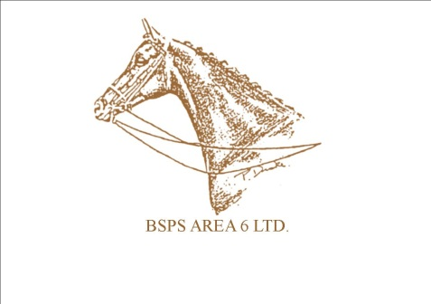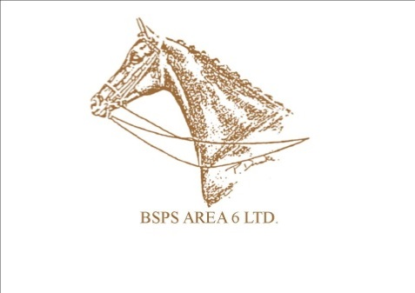

**BSPS Area 6**

**Points Presentation Sponsorship**

**Saturday 27th January 2024**

For 2023/24 we have a range of sponsorship opportunities available. We would be most grateful to anyone that would like to sponsor a section at the 2021/22 presentation. Should you wish to do so, please select the classes you wish to sponsor and return this form with the payment to **BSPS AREA 6 Ltd to Mary Allison, 55,Princethorpe Drive, Banbury OX 16 4FN ( 07870452399 )** If your chosen classes are no longer available for sponsorship we will try to allocate a suitable alternative for you. If you have any questions please contact Mary. Please send by 9th December 2023

**ClassSponsorship**The following classes are available for sponsorship at a cost of £10 per class. Your name ( or your preferred wording ) will be on the rosettes..

**Show Hunter Ponies:**

* Lead Rein
* First Pony of Hunter Type
* 122cm
* 133cm
* 143cm
* 153cm
* Intermediate SH

**Working Hunter Ponies:**

* Cradle Stakes
* Nursery Stakes
* 133cm
* 143cm
* 153cm
* Intermediate WH

**Show Ponies:**

* Lead Rein
* First Ridden
* 128cms
* 138cms
* 148cms
* Intermediate SRT

**Heritage Mountain and Moorland**

* M&M Lead Rein
* M&M First Ridden
* M&M Small Breeds
* M&M Large Breeds
* M&M Working Hunter Ponies
* M&M Junior Ridden

**Champion sponsorship**The following championships are available for sponsorship at a cost of £25 per championship. This will include sponsor name and contact details on the rosettes/sashes

* Show Hunter Ponies
* Mountain and Moorland
* Working Hunter Ponies
* Show ponies

Wording for rosettes /sashes